Merlin Ranch Platinum-Level Sponsor of
2019 Wyoming Women's Antelope Hunt

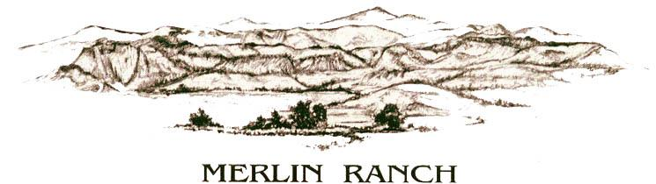

LARAMIE, WY- Merlin Ranch, owned by Jennie Muir Gordon and her husband, Wyoming Governor Mark Gordon, boasts predominantly Angus and Angus-cross cattle in the red scoria hills outside of Buffalo, Wyoming. Jennie's family took over the ranch in 1988 and have been dedicated to being good stewards of the rangeland for future generations. The Merlin Ranch shows stewardship not just of their rangeland but of their community, having committed once again to a Platinum-Level Sponsorship for the 2019 Wyoming Women's Antelope Hunt.

This year will mark First Lady Jennie Gordon's seventh year at the Wyoming Women's Antelope Hunt, and her first as the First Lady of Wyoming. As First Lady, Jennie Gordon has expressed support of the Wyoming Women's Antelope Hunt to empower women in Wyoming and beyond.

"The difference this hunt makes in the lives of women is obvious," said First Lady Gordon. "I've returned year after year because of the positive impact towards women's self-sufficiency. Giving women the opportunity to provide food for themselves and their families ties in perfectly with my Wyoming Hunger Initiative. This hunt is another opportunity to support women and to help end childhood hunger in Wyoming."

"Merlin Ranch's consistent partnership with our annual event has been paramount to the hunt's success," said Rebekah Smith, Wyoming Women's Foundation Director. "We really appreciate the Gordon's continued support and participation to raise funds for Wyoming Women. We hope they will continue to partner and hunt with us for years to come!" added Smith.

This year's hunt will be held Oct. 10-13, 2019 and will bring together more than 40 female hunters from across the nation at the Ranch at Ucross in northeast Wyoming for a weekend of hunting, learning, mentorship and camaraderie, as well as raising funds and awareness for the Wyoming Women's Foundation.

Please visit the Wyoming Women's Antelope Hunt webpage at wyomingwomensantelopehunt.org for more information on sponsorship and individual participation, including scholarships. Based on its level of contribution, each sponsor has the opportunity to invite women to hunt at the event. The foundation is also seeking dinner sponsors and in-kind donations for its fundraising auction dinner on Friday, Oct. 11.

